Circuit Diagram
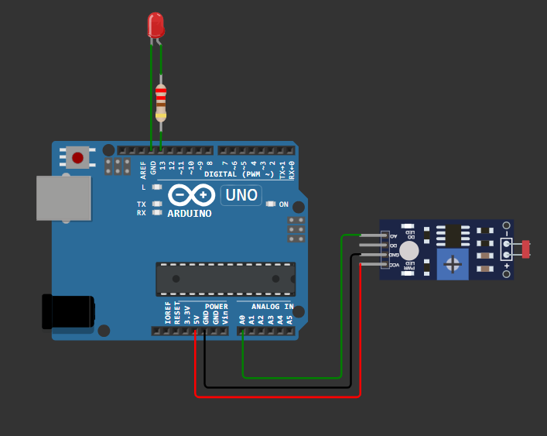
Source of Code
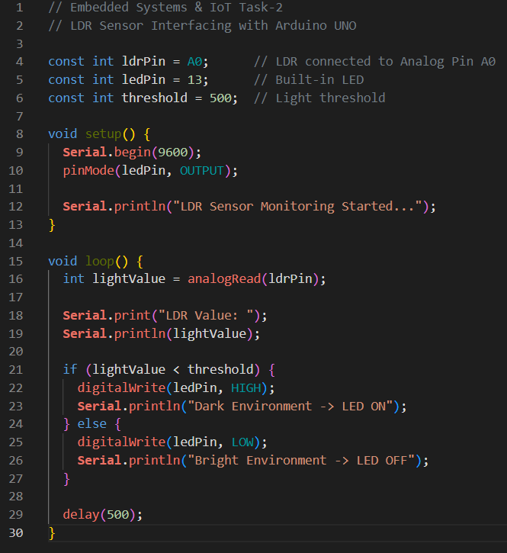
Explanation
The Light Dependent Resistor (LDR) is a photoresistor that detects the intensity of light in the surrounding environment. Its electrical resistance changes depending on the amount of light falling on its surface. When the environment is bright, the resistance of the LDR decreases, resulting in a higher analog reading. In dark conditions, the resistance increases, causing the analog reading to change accordingly. The Arduino continuously reads this analog value through the A0 input pin and uses it to determine the current light intensity. This enables the system to automatically respond to changes in ambient lighting without requiring any manual intervention.
The Arduino program continuously monitors the light intensity by reading the analog value from the LDR sensor. The sensor reading is displayed on the Serial Monitor so that the current light level can be observed in real time. The program then compares the sensor value with a predefined threshold. If the light intensity is below the threshold, indicating a dark environment, the Arduino switches the LED ON to provide illumination. When the light intensity is above the threshold, indicating sufficient brightness, the LED is turned OFF. A short delay is included after each reading to ensure stable operation, reduce unnecessary switching, and improve the reliability of the system.

